Software Engineering Assignment

MODULE: 1

SE – Overview of IT Industry

1. What is software? What is software engineering?

* Software is a set of instructions, programs, or data used to operate computers and perform specific tasks. It includes everything from operating systems like Windows or IOS to applications like Microsoft Word, Photoshop, or even mobile apps like Instagram or Uber. Software tells hardware what to do and how to do it, enabling computers and devices to perform various functions according to user input.
* Software Engineering is the process of designing, developing, testing, and maintaining software. It includes a variety of techniques, tools, and methodologies, including requirements analysis, design, testing, and maintenance.

1. Explain types of software.
2. Application software

* This is the most common types of software. This software is designed to perform specific tasks or provide functionality for end-users. It includes word processors, spreadsheets, database management, etc.

1. System software

* System software is a program, designed to run a computer's hardware and applications and manage its resources, such as its memory, processors, and devices. It also provides a platform for running application software.

1. Driver software

* It is a type of system software that facilitates communication between the operating system and hardware devices attached to a computer. It plays a critical role in enabling the seamless integration and operation of hardware devices within a computer system.

1. Middleware

* Middleware acts as an intermediary between different software applications, enabling communication and data exchange between them. Examples include

database management systems, web servers, and enterprise application integration software.

1. Programming software

* Programming software, also known as development tools or software development environments, are applications used by developers to create, debug, test, and maintain software programs and applications. These tools provide an integrated environment that facilitates the entire software development process.

1. What is SDLC? Explain each phase of SDLC.

* SDLC stands for Software Development Life Cycle. It refers to the process used by software development teams to design, develop, test, deploy, and maintain software applications or systems. The SDLC consists of several phases, each with its own set of activities and deliverables, aimed at ensuring the successful completion of a software project. While specific methodologies and approaches may vary, the core phases of the SDLC typically include:
* Planning: In this initial phase, project stakeholders define the scope, objectives, requirements, and constraints of the software project. This may involve conducting feasibility studies, gathering user requirements, defining project goals, and creating a project plan and timeline.
* Analysis: During this phase, the project team analyzer the gathered requirements in detail to understand the needs and expectations of users, stakeholders, and other relevant parties. This involves defining system specifications, creating use cases, modeling workflows, and identifying potential risks and challenges.
* Design: In this phase, the system architecture and design are developed based on the requirements and specifications gathered in the previous phases. This includes designing the overall system structure, defining data models and databases, creating user interfaces, and detailing the software's internal components and modules.
* Implementation: Also known as coding or development, this phase involves writing, testing, and integrating the software code according to the design specifications. Developers follow coding standards and best practices to build functional, efficient, and maintainable software components, modules, and systems.
* Testing: In this phase, the software is rigorously tested to identify and fix defects, errors, and vulnerabilities. This includes various types of testing such as unit testing, integration testing, system testing, and acceptance testing, as well as techniques like manual testing and automated testing.
* Maintenance: The final phase of the SDLC involves maintaining and supporting the software throughout its lifecycle. This includes fixing bugs and issues, implementing updates and enhancements, optimizing performance, and addressing changing user requirements and business needs.

1. What is DFD? Create a DFD diagram on Flipkart.

* DFD stands for Data Flow Diagram. It's a graphical representation of the flow of data through a system, illustrating how data is input to, processed within, and output from the system. In a DFD, processes are represented as rectangles, data stores as parallel lines, data flows as arrows, and external entities as squares.

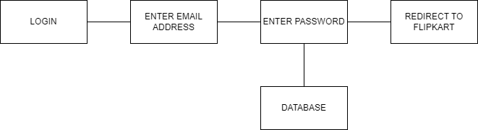

1. What is Flow chart? Create a flowchart to make addition of two numbers.

* Flowchart is a graphical representation of a process or workflow, showing the sequence of steps or actions required to achieve a specific goal. It uses symbols and connecting lines to depict the flow of information, materials, or tasks through the various stages of the process. Flowcharts are commonly used in various fields such as software development, business process management, engineering, education, and project management.

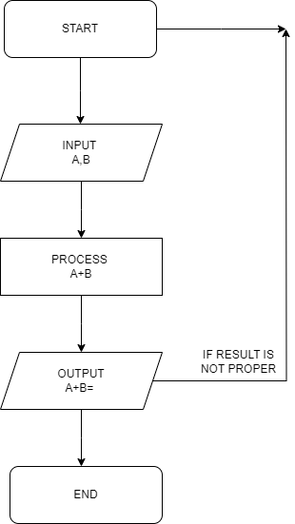

1. What is Use case Diagram? Create a use-case on bill payment on paytm.

* A use case diagram is a graphical depiction of a user's possible interactions with a system. A use case diagram shows various use cases and different types of users the system has and will often be accompanied by other types of diagrams as well. The use cases are represented by either circles or ellipses.

